**Project Setup for the given Case study**

I have implemented the below projects as part of Front-end architecture design implementation.

React Projects:

1. Root MFE
2. Header MFE
3. Content MFE
4. Header MFE
5. Design System MFE

Node JS with Graphiql Interface Project

1. UI configuration service with GraphiQL interface

Pre-Requisite – Node JS version 16+

Steps to setup all the above projects

1. Go to the Project location in command prompt
2. Run npm install command
3. Run npm start command
4. Please do above 3 steps for the projects such as Root, Header, Content, Footer, Design System and UI Configuration service in the same order.
5. Go to <http://localhost:9000> to see the UI application
6. Go to <http://localhost:4000/graphql> to see the GraphiQL interface

**UI Application screen shot**

1. **Default US location screen shot**

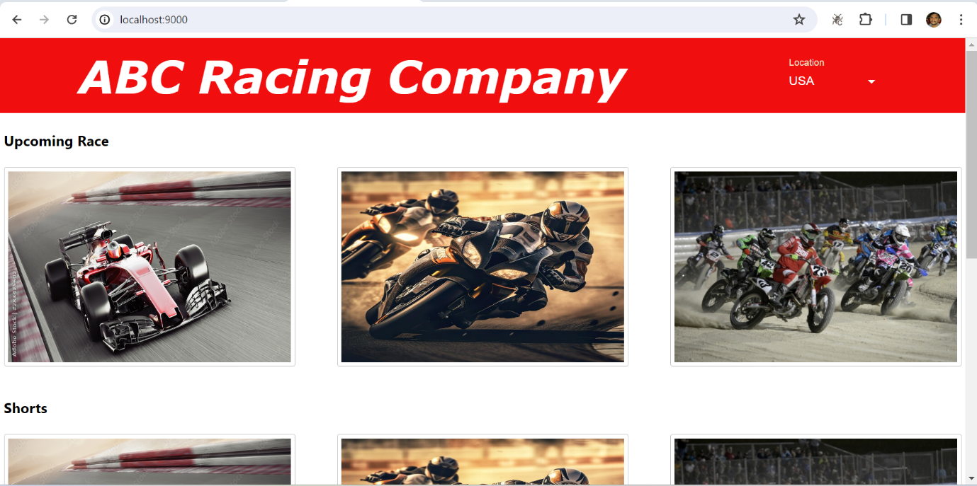

1. **India location screen shot**

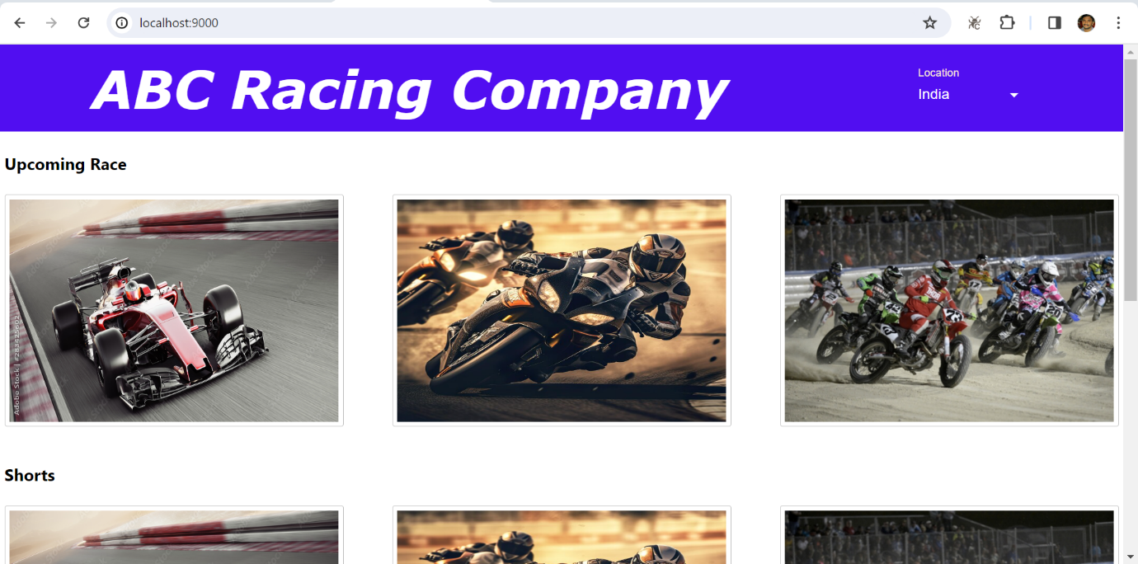

**GraphiQL Interface screenshot**

